**Pharmacy System**

**White Box Testing**

**Function:** Search Button (search_page.java).

**Fun. Located:** From 134 - To 178.

**Code:**

private void jButtonsearchActionPerformed(java.awt.event.ActionEvent evt)

{

String medicineName=SearchTextField.getText();

if(medicineName.isEmpty())

{

JOptionPane.showMessageDialog(this,"Please , Enter your a medicine name");

return;

}

Connection con = null;

Statement stmt = null;

ResultSet result = null;

try

{ ……………………………………………………………………………………………

if(result.next())

{

int amount = result.getInt("amount");

notes = result.getString("notes");

if(amount==0)

JOptionPane.showMessageDialog(this,"medicine out of stock "+notes);

else JOptionPane.showMessageDialog(this,"medicine available "+notes);

}

else

{

JOptionPane.showMessageDialog(this,"Invalid medicine name");

}

}catch(Exception ex)

{

………………………………………………………………………………………

}

finally

{

………………………………………………………………………………………

}

}

**Testing Graph:**

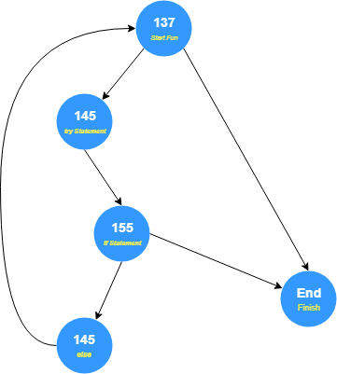

**Cyclomatic Complexity:**

* **V(G)= Closed Path +1 =** 2+1= 3.
* **V(G)= Predicates + 1 =** 2 + 1 = 3.
* **V(G)= E-N +2 =** 6-5+2 = 3.

**Paths:**

**#1: 137,END.**

**#2: 137,145,155,145,137.**

**Function:** Add Amount Button <Tab:Edit Amount> (Data_Entry.java).

**Fun. Located:** From 354 - To 410.

**Code:**

private void jButton2ActionPerformed(java.awt.event.ActionEvent evt)

{

String name=jTextField2.getText();

System.err.println("ww");

String am =jTextField3.getText();

int amount=Integer.parseInt(am);

int Amount = 0;

if(name.isEmpty()){

JOptionPane.showMessageDialog(this, "Please enter medicine name");

return;

}

if(am.isEmpty()){

JOptionPane.showMessageDialog(this, "Please amount Of Medicine");

return;

}

Connection con = null;

Statement comand=null;

ResultSet rst =null;

try {

………………………………………………………………

String a="select * from medicine "+"WHERE m_name='"+name+"'";

rst = comand.executeQuery(a);

if(rst.next())

{

Amount = rst.getInt("amount");

}

{

JOptionPane.showMessageDialog(this,"Invalid medicine name");

}

String sql = ("UPDATE medicine set amount="+(amount+Amount)+"WHERE m_name='"+name+"'") ;

int affectsRows = comand.executeUpdate(sql);

if(affectsRows == 1)

{

JOptionPane.showMessageDialog(this, "Successful Update Amount ");

}

else

{

JOptionPane.showMessageDialog(this, "Incorrect Amount !!!");

}

**Testing Graph:**

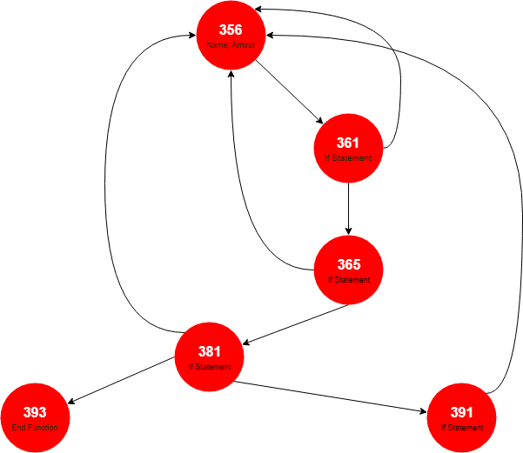

**Cyclomatic Complexity:**

* **V(G)= Closed Path +1 =** 4+1= 5.
* **V(G)= Predicates + 1 =** 4 + 1 = 5.
* **V(G)= E-N +2 =** 9-6+2 = 5.

**Paths:**

**#1: 356,361,365,381,393.**

**#2: 356,361,356.**

**#3: 356,361,365,356.**

**#4: 356,361,365,381,356.**

**#5: 356,361,365,381,391,356**